KKAX -

Functionality
The WIP calculation process valuates the unfinished products (work in process).
In the Product Cost by Order component, the work in process is valuated at actual costs. Work in process is the difference between the debit and credit of an order that has not been completely delivered. This method determines the work in process for each production order by calculating the difference between the actual costs incurred and the actual costs settled (that is, the difference between the debits for goods issues, internal activity allocations, external activities, and overhead on the one hand, and the credits for goods receipts on the other). Once the last part of the order lot has been delivered to stock, any remaining work in process must be canceled so that the order costs can properly be settled to stock.
The status of the order determines whether WIP calculation creates or cancels the work in process.
- If the order has the status REL (released), the system can calculate work in process.
- Once the order receives the status DLV (Delivered) or TECO (Technically completed), the work in process calculated in a previous period is canceled.

Scenario
As a part of the period end processing, Work in process needs to be calculated prior to variance calculation and settlement for accurate period end closing. We want to calculate WIP independently per production order.

Requirements
Production order has been released.

Menu Path | Accounting → Controlling → Product Cost Controlling → Cost Object Controlling → Product Cost by Order → Period-End Closing → Single Functions → Work in Process → Individual Processing → KKAX - Calculate
Transaction Code | KKAX

1. Double click on KKAX - Calculate

Calculate Work in Process: Individual Processing

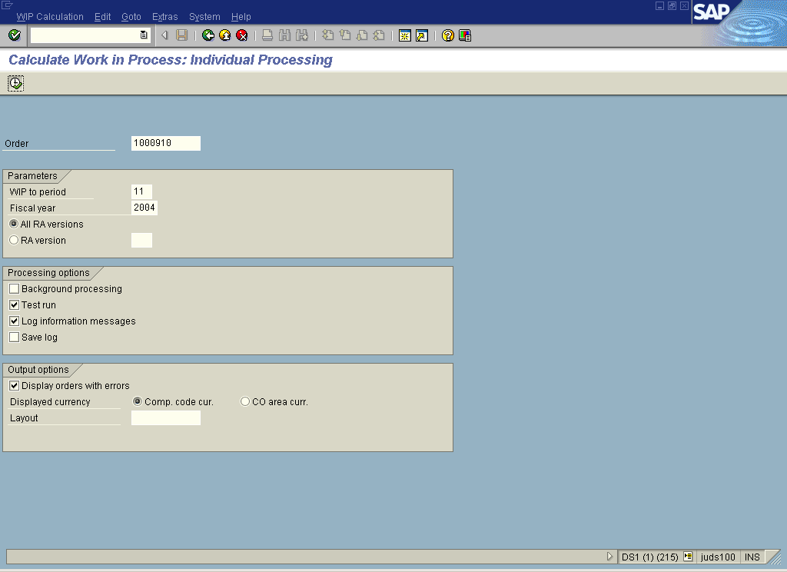

2. Update the following fields:

Field Name | Field Description | Values
Order | Number identifying the order | Enter value in Order.  Example: 1000910
WIP to period | Description of the WIP to period. | Enter value in WIP to period.  Example: 11
Fiscal year | Description of the Fiscal year. | Enter value in Fiscal year.  Example: 2004

3. Click <radio button> All RA versions .

4. Click Execute

Calculate Work in Process: Object List

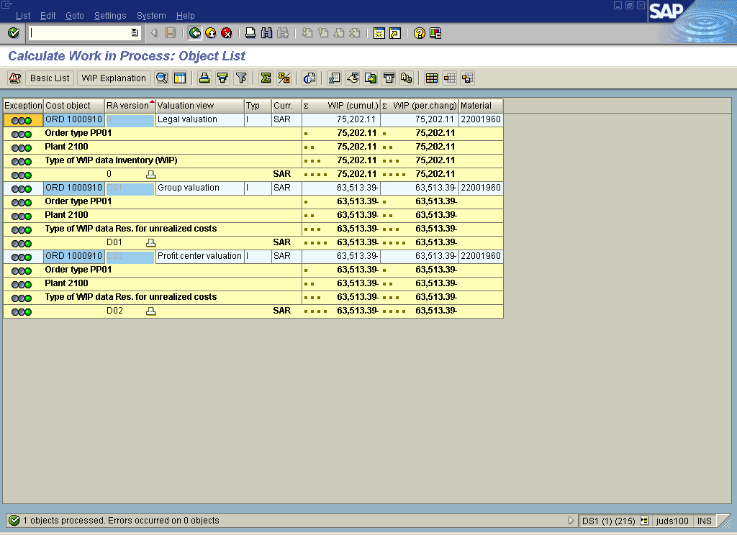

Note: The WIP results are presented per valuation view i.e. Legal, Group and Profit center valuation view.
5. Click Back

Exit list

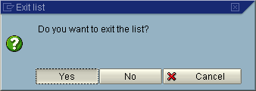

6. Click Yes Button .

Calculate Work in Process: Individual Processing

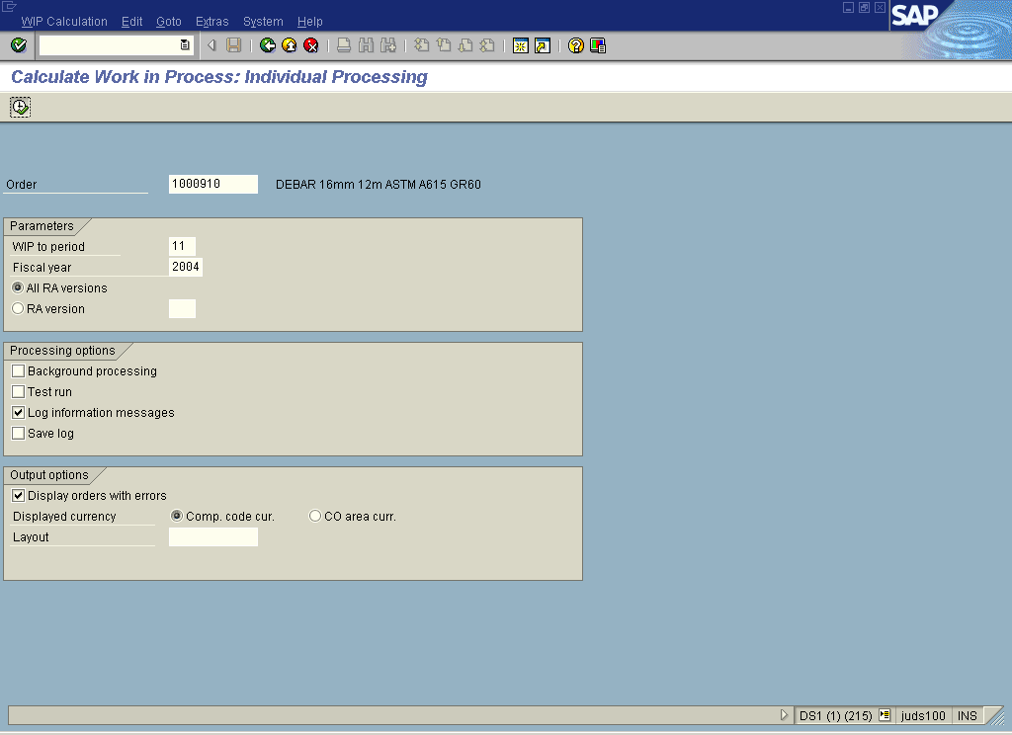

7. Click <checkbox> Test run .

8. Click Execute

Calculate Work in Process: Object List

9. Click Back

Exit list

10. Click Yes Button .

